M.NAVEEN
192411134
COURSE CODE :- CSA0652

CO3 ASSESSMENT TOOL 2
QUESTION -2

Case Study: Scientific Computing (Matrix Multiplication)
A scientific application performs repeated matrix multiplications for simulations. Analyze how divide and conquer techniques can improve computational efficiency. Identify the challenges involved in handling large matrices, such as increased computational cost and memory requirements. Apply an optimized matrix multiplication technique, such as Strassen's method, to improve performance. Analyze the time complexity of Strassen's algorithm and compare it with the traditional matrix multiplication approach. Design a suitable solution using Strassen's Matrix Multiplication and justify its advantages

SOURCE CODE :-
#include <stdio.h>
int main() {
int A[2][2], B[2][2], C[2][2];
int M1, M2, M3, M4, M5, M6, M7;
printf("Enter elements of Matrix A:\n");
for (int i = 0; i < 2; i++)
for (int j = 0; j < 2; j++)
scanf("%d", &A[i][j]);
printf("Enter elements of Matrix B:\n");
for (int i = 0; i < 2; i++)
for (int j = 0; j < 2; j++)
scanf("%d", &B[i][j]);
M1 = (A[0][0] + A[1][1]) * (B[0][0] + B[1][1]);
M2 = (A[1][0] + A[1][1]) * B[0][0];
M3 = A[0][0] * (B[0][1] - B[1][1]);
M4 = A[1][1] * (B[1][0] - B[0][0]);
M5 = (A[0][0] + A[0][1]) * B[1][1];
M6 = (A[1][0] - A[0][0]) * (B[0][0] + B[0][1]);
M7 = (A[0][1] - A[1][1]) * (B[1][0] + B[1][1]);
C[0][0] = M1 + M4 - M5 + M7;
C[0][1] = M3 + M5;
C[1][0] = M2 + M4;
C[1][1] = M1 - M2 + M3 + M6;
printf("\nResultant Matrix:\n");
for (int i = 0; i < 2; i++) {
for (int j = 0; j < 2; j++)
printf("%d ", C[i][j]);
printf("\n");
}
return 0;
}

OUTPUT SCREENSHOTS
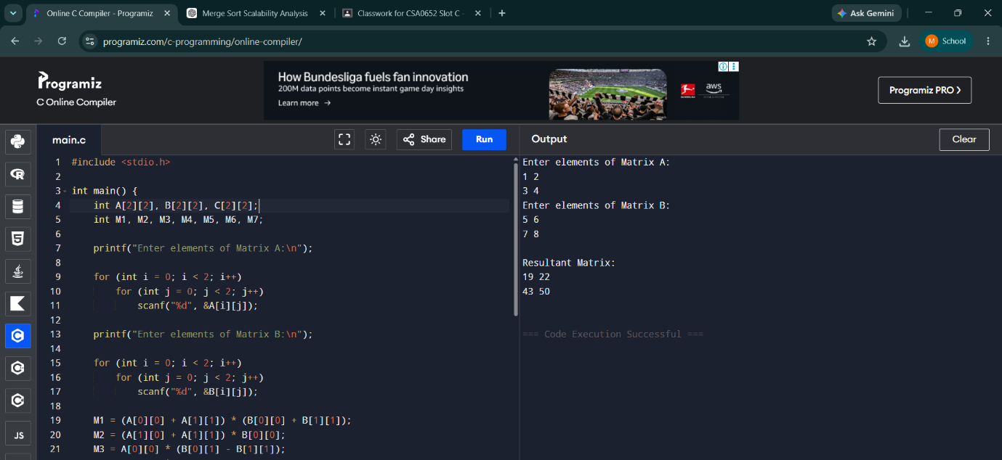

Additional Supporting Files
sample_matrices.txt
Matrix A:
1 2
3 4
Matrix B:
5 6
7 8
complexity_comparison_table.txt
Method Complexity
Traditional O(n^3)
Strassen O(n^2.81)
Graph:
Matrix Size (X-axis)
Execution Time (Y-axis)
Traditional Method
Strassen Method

